Personal Auto Page and Data Specifications Final Assessment

Missouri Personal Auto Page and Data Specifications
Applicant
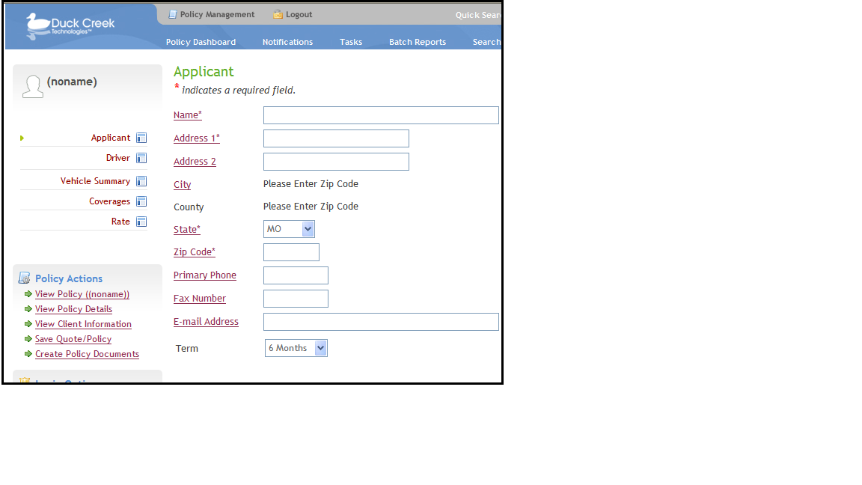

Applicant Page – Specifications
Field Caption | Field Name | Field Path | Data Type | Reqd | Default Value | Max Length | Pick List Values | Pick List Captions | Rules & Other Information
Name | AccountInput.Name | Name | String | Yes |  | inherited
Address 1 | AccountInput.Address1 | address/Address1 | String | Yes |  | inherited
Address 2 | AccountInput.Address2 | address/Address2 | String | No |  | inherited
City | AccountInput.City | address/City | String | No |  | inherited |  |  | - Read-Only. Should Auto-Populate According to ZipCode entered. Make sure Tables are using Default.  - Compute Value
County | AccountInput.County | County | String | No |  | inherited |  |  | - Read-Only. Should Auto-Populate According to ZipCode entered. Make sure Tables are using Default.  - Compute Value
State | AccountInput.State | address/State | String | Yes | MO | inherited | State Option List | State Option List Inherited | - Format Mask: Blank Option Select
Zip Code | AccountInput.ZipCode | address/ZipCode | String | Yes |  | inherited |  |  | - Format Mask: Zipcode, Refresh Page on Change
Primary Phone | AccountInput.PrimaryPhone | PrimaryPhone | String | No |  | inherited |  |  | - Format Mask: PhoneFax
Fax Number | AccountInput.Fax | Fax | String | No |  | inherited |  |  | - Format Mask: PhoneFax
E-Mail Address | AccountInput.Email | Email | String | No |  | inherited
Term | PolicyInput.Term | Term | Int | No | 6 | inherited | 6  12 | 6 Months  1 Year

Driver
Driver

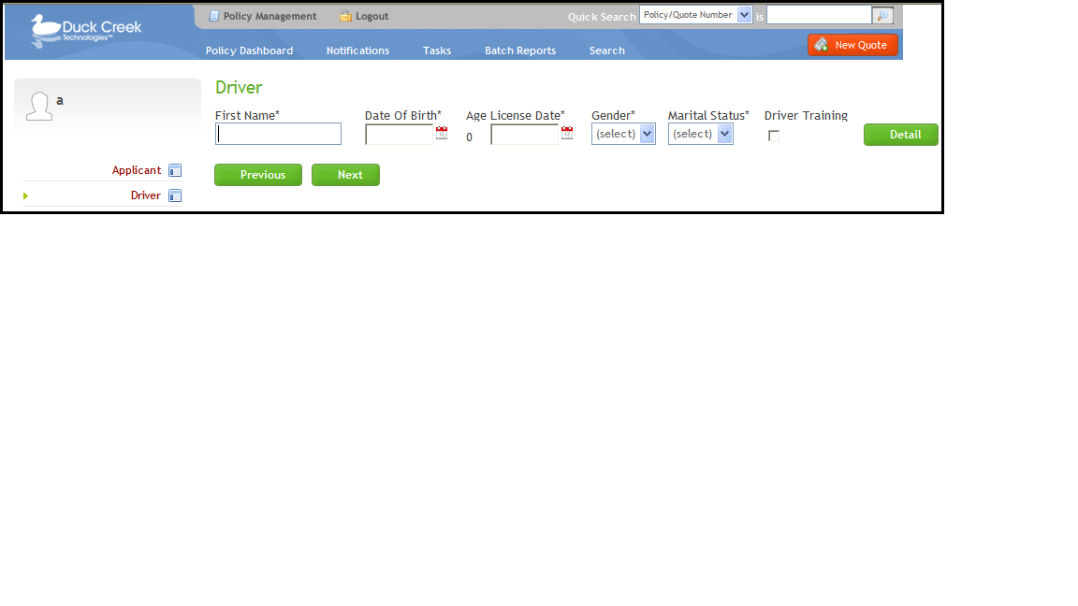

Driver Page – Specifications
Pre-fill fields on this page with corresponding data user enters in the Quick Quote.
Field Caption | Field Name | Field Path | Data Type | Reqd | Default Value | Max Length | Pick List Values | Pick List Captions | Rules & Other Information
First Name | DriverInput.FirstName | FirstName | String | Yes |  | 15
Date Of Birth | DriverInput.DateOfBirth | DateOfBirth | Date | Yes |  | MaxLength.Date |  |  | - Refresh on change.
Age | DriverOutput.Age | DriverAge | Int |  |  | MaxLength.Value |  |  | - Calculate the driver age based upon the driver date of birth.  - Compute Value.  - Read only.  - Display a “0” until a date of birth is entered. Compute Value in Page Designer
License Date | DriverInput.LicenseDate | LicenseDate | Date | Yes |  | MaxLength.Date
Gender | DriverInput.Gender | Gender | String | Yes |  | 10 | Female  Male | Female  Male | - Format Mask: Blank Option Select
Marital Status | DriverInput.MaritalStatus | MaritalStatus | String | Yes |  | 10 | Single  Married | Single  Married | - Format Mask: Blank Option Select
Driver Training | DriverInput.DriverTraining | DriverTraining | Boolean | No | False | 1 |  |  | - Applicable only if a driver is less than 21 years of age.
Driver Detail Button
- Caption: Detail
- Take user to the Driver Detail Pop-Up page, which displays the detail for the corresponding driver record.

Driver Detail Pop-Up

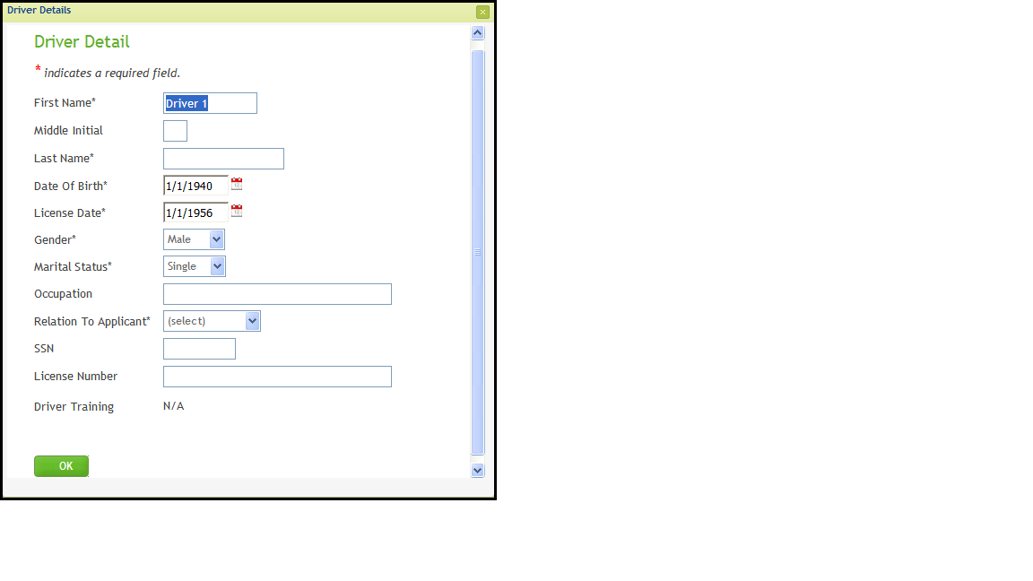

Driver Detail Page – Specifications
Pre-fill fields on this page with corresponding data user enters on the Driver Page
Field Caption | Field Name | Field Path | Data Type | Reqd | Default Value | Max Length | Pick List Values | Pick List Captions | Rules & Other Information
First Name | DriverInput.FirstName | FirstName | String | Yes |  | 15
Middle Initial | DriverInput.MiddleInitial | MiddleInitial | String | No |  | 2
Last Name | DriverInput.LastName | LastName | String | Yes |  | 20
Date Of Birth | DriverInput.DateOfBirth | DateOfBirth | Date | Yes |  | MaxLength.Date
License Date | DriverInput.LicenseDate | LicenseDate | Date | Yes |  | MaxLength.Date
Gender | DriverInput.Gender | Gender | String | Yes |  | 10 | Female  Male | Female  Male | - Format Mask: Blank Option Select
Marital Status | DriverInput.MaritalStatus | MaritalStatus | String | Yes |  | 10 | Single  Married | Single  Married | - Format Mask: Blank Option Select
Occupation | DriverInput.Occupation | Occupation | String | No |  | 40
Relation To Applicant | DriverInput.RelationToApplicant | RelationToApplicant | String | Yes |  | 20 | NamedInsured  Spouse  Child  Sibling  Parent  Roommate | Named Insured  Spouse  Child  Sibling  Parent  Roommate | - Format Mask: Blank Option Select
SSN | DriverInput.SocialSecurityNumber | SocialSecurityNumber | String | No |  | 11
License Number | DriverInput.DriversLicenseNumber | DriversLicenseNumber | String | No |  | 40
Driver Training | DriverInput.DriverTraining | DriverTraining | Boolean | No | False | 1 |  |  | - Applicable only if a driver is less than 21 years of age.
OK Button
- Caption: OK
- Take user from the Driver Detail Pop-Up page back to the Driver page.

Vehicle Summary
Single Vehicle

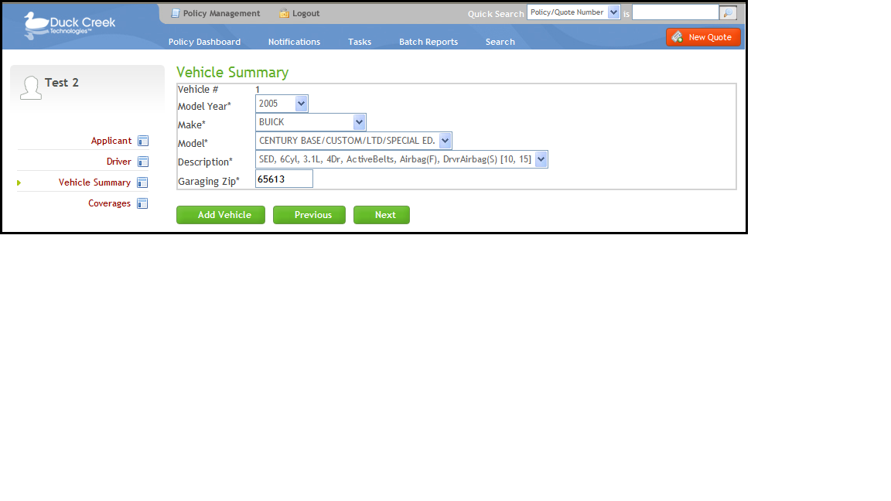
Multiple Vehicles

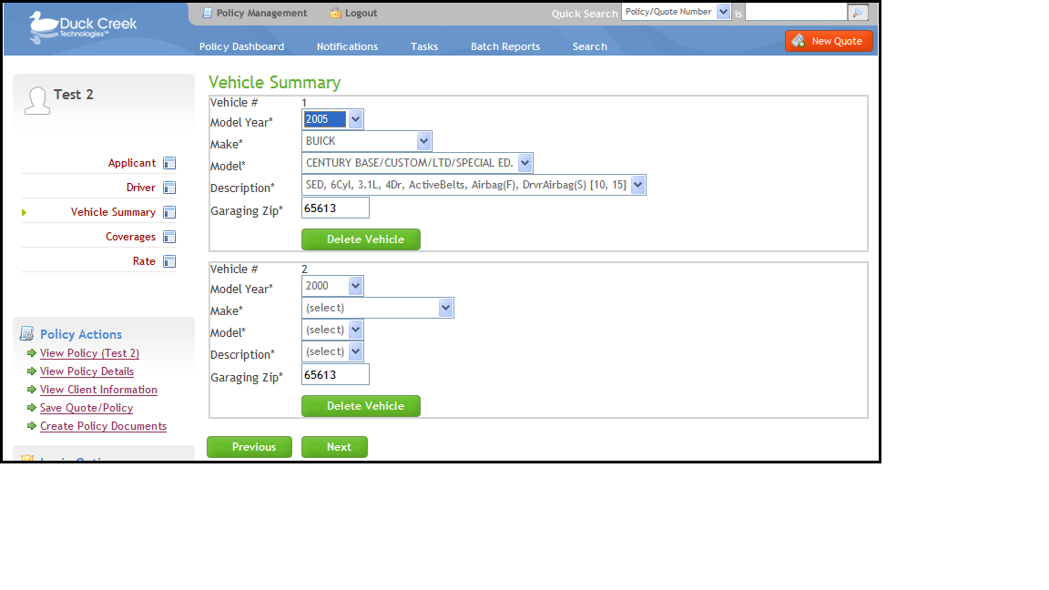

Vehicle Summary Page – Specifications
Field Caption | Field Name | Field Path | Data Type | Reqd | Default Value | Max Length | Pick List Values | Pick List Captions | Rules & Other Information
Vehicle # | RiskOutput.VehicleNumber | VehicleNumber | Int |  |  | 1 |  |  | - Display number as read only and increment by one for each additional vehicle, starting with 1.  - Compute Value
Model Year | RiskInput.ModelYear | ModelYear | Int | Yes | 2000 | 4 | Data Services generated | Data Services generated | - Format Mask: Blank Option Select  - Refresh on change.
Make | RiskInput.Make | Make | String | Yes |  | 80 | Data Services generated | Data Services generated | - Format Mask: Blank Option Select  - Refresh on change.  - Compute Value
Model | RiskInput.Model | Model | String | Yes |  | 80 | Data Services generated | Data Services generated | - Format Mask: Blank Option Select  - Refresh on change.  - Compute Value
Description | RiskInput.Description | Description | String | Yes |  | 80 | Data Services generated | Data Services generated | - Format Mask: Blank Option Select
Garaging Zip | GaragingAddress.ZipCode | ZipCode | String | Yes | AccountInput.zipCode | 5
Delete Button
- Caption: Delete Vehicle
- Delete the associated vehicle record.
- Display only when there is more than one vehicle record.
Add Button
- Caption: Add Vehicle
- Add a vehicle record.
- Do not display after there are 2 vehicle records.

Coverages

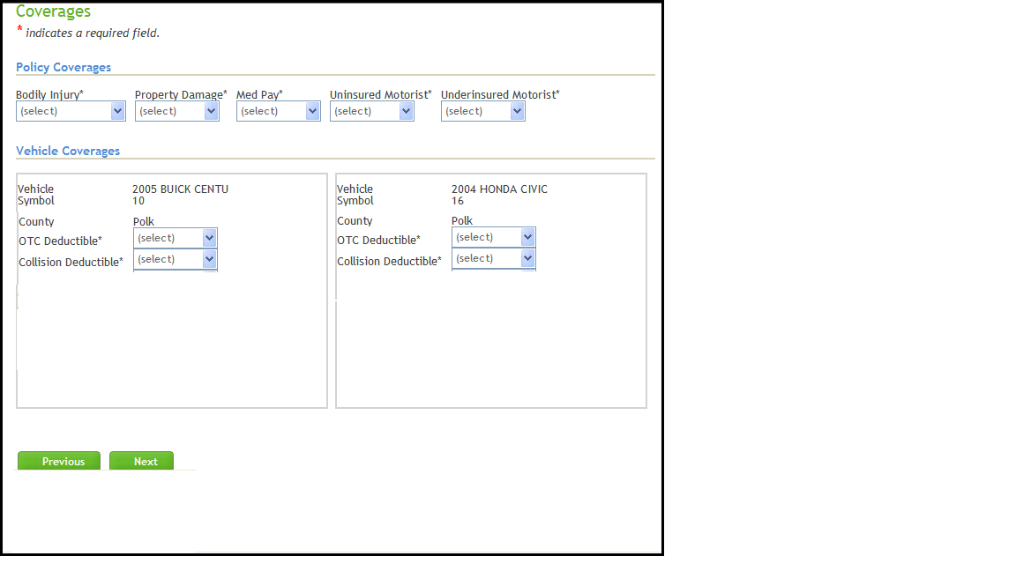

Coverages Page – Specifications
Pre-fill fields on this page with corresponding data entered in Vehicle Summary page and display information for up to 4 vehicles without horizontal scrolling. (*Use Maximum Iterations on the Risk Group in Page Designer)
Field Caption | Field Name | Field Path | Data Type | Reqd | Default Value | Max Length | Pick List Values | Pick List Captions | Rules & Other Information
Bodily Injury | LineInput.LimitBodilyInjury | LimitBodilyInjury | String | Yes |  | 20 | 25000/50000  50000/100000  100000/200000  100000/300000  300000/300000  250000/500000  60000CSL  75000CSL  100000CSL  200000CSL  300000CSL  500000CSL | $25,000/$50,000  $50,000/$100,000  $100,000/$200,000  $100,000/$300,000  $300,000/$300,000  $250,000/$500,000  $60,000 CSL  $75,000 CSL  $100,000 CSL  $200,000 CSL  $300,000 CSL  $500,000 CSL | - Format Mask: Blank Option Select  - Refresh on change.
Property Damage | LineInput.LimitPropertyDamage | LimitPropertyDamage | Int | Yes |  | 10 | -1  10000  15000  20000  25000  50000  100000  150000  200000  250000  0 | No Coverage  $10,000  $15,000  $20,000  $25,000  $50,000  $100,000  $150,000  $200,000  $250,000  Included | - If the Bodily Injury limit is a CSL limit, set the value of this field is 0 (Included) and read only.  - Do not display the caption “Included” in the picklist when the Bodily Injury limit is a split.  - Format Mask: Blank Option Select  - Compute Value.
Med Pay | LineInput.LimitMedicalPayments | LimitMedicalPayments | Int | Yes |  | 10 | -1  1000  2000  5000  10000 | No Coverage  $1,000  $2,000  $5,000  $10,000 | - Format Mask: Blank Option Select
Uninsured Motorist | LineInput.LimitUninsuredMotorist | LimitUninsuredMotorist | String | Yes |  | 20 | -1  25000/50000  50000/100000  100000/200000  100000/300000  300000/300000  250000/500000  60000CSL  75000CSL  100000CSL  200000CSL  300000CSL  500000CSL | No Coverage  $25,000/$50,000  $50,000/$100,000  $100,000/$200,000  $100,000/$300,000  $300,000/$300,000  $250,000/$500,000  $60,000 CSL  $75,000 CSL  $100,000 CSL  $200,000 CSL  $300,000 CSL  $500,000 CSL | - Format Mask: Blank Option Select  - Display limit captions in the pick list only if they are less than or equal to the chosen Bodily Injury limit.  - Display split limit captions in the pick list only if the chosen Bodily Injury limit is a split limit.  - Display CSL limit captions only if the chosen Bodily Injury limit is a CSL.
Underinsured Motorist | LineInput.LimitUnderinsuredMotorist | LimitUnderinsuredMotorist | String | Yes |  | 20 | -1  25000/50000  50000/100000  100000/200000  100000/300000  300000/300000  250000/500000  60000CSL  75000CSL  100000CSL  200000CSL  300000CSL  500000CSL | No Coverage  $25,000/$50,000  $50,000/$100,000  $100,000/$200,000  $100,000/$300,000  $300,000/$300,000  $250,000/$500,000  $60,000 CSL  $75,000 CSL  $100,000 CSL  $200,000 CSL  $300,000 CSL  $500,000 CSL | - Format Mask: Blank Option Select  - Display limit captions in the pick list only if they are less than or equal to the chosen Bodily Injury limit.  - Display split limit captions in the pick list only if the chosen Bodily Injury limit is a split limit.  - Display CSL limit captions only if the chosen Bodily Injury limit is a CSL.
Vehicle | RiskOutput.YearMakeModel | YearMakeModel | String |  |  | 80 |  |  | - Read only.  - Compute Value.  - Concatenate the vehicle model year, make and 5-char model. Will need to build a substring to extract the first 5 chars of RiskInput.Model
Symbol | RiskOutput.Symbol | Symbol | Int |  |  | 2 |  |  | - Read only.  - Compute Value.  - Return the rating symbol form Data Services based up the vehicle description.  - For testing in Data Tester, hard code to 10.
County | GaragingAddress.County | GaragingAddressCounty | String | Yes |  | 20 | MO County List | MO County List | - Read-Only  - Compute Value
OTC Deductible | OTCInput.Deductible | Deductible | Int | Yes |  | 10 | -1  0  50  100  200  250  500  1000 | No Coverage  0  $50  $100  $200  $250  $500  $1,000 | - Format Mask: Blank Option Select
Collision Deductible | CollisionInput.Deductible | Deductible | Int | Yes |  | 10 | -1  100  200  250  500  1000 | No Coverage  $100  $200  $250  $500  $1,000 | - Format Mask: Blank Option Select

Rate

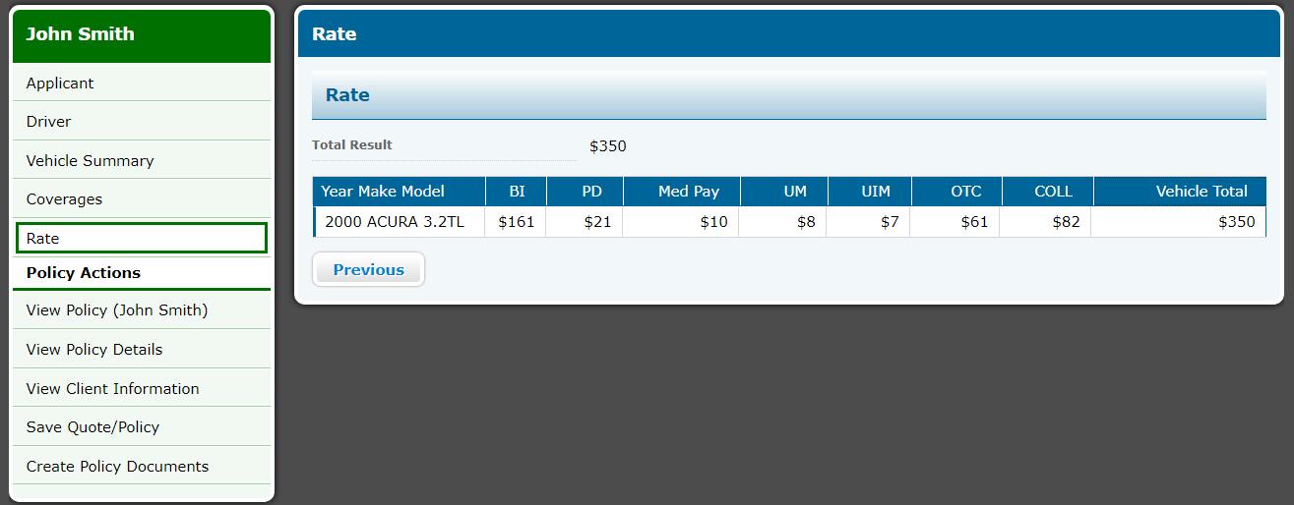

Rate Page – Specifications
Set page to read only.
Rate a quote upon entering the screen (execute and accept).
Display vehicle coverage premium detail for all vehicles in the quote.
Field Caption | Field Name | Field Path | Data Type | Reqd | Default Value | Max Length | Pick List Values | Pick List Captions | Rules & Other Information
Total Result | data.TotalResult | TotalResult | Int |  |  | inherited |  |  | - Format Mask: Premium
Vehicle | RiskOutput.YearMakeModel | YearMakeModel | String |  |  | MaxLength.Premium |  |  | - Concatenate the vehicle model year, make and model.
BI | BIOutput.Premium | Premium | Float |  |  | MaxLength.Premium |  |  | - Format Mask: Premium
PD | PDOutput.Premium | Premium | Float |  |  | MaxLength.Premium |  |  | - Format Mask: Premium
Med Pay | MedPayOutput.Premium | Premium | Float |  |  | MaxLength.Premium |  |  | - Format Mask: Premium
UM | UMOutput.Premium | Premium | Float |  |  | MaxLength.Premium |  |  | - Format Mask: Premium
UIM | UIMOutput.Premium | Premium | Float |  |  | MaxLength.Premium |  |  | - Format Mask: Premium
OTC | OTCOutput.Premium | Premium | Float |  |  | MaxLength.Premium |  |  | - Format Mask: Premium
COLL | CollisionOutput.Premium | Premium | Float |  |  | MaxLength.Premium |  |  | - Format Mask: Premium
Vehicle Total | RiskOutput.Premium | Premium | Float |  |  | MaxLength.Premium |  |  | - Format Mask: Premium

